*A project report on*

**DMART SALES ANALYSIS**

*Submitted in partial fulfillment for the award of the degree of*

**B.Tech Computer Science**

**with specialization in Data Analytics**

*by*

**MOHAJIT NEOG (21BCE8170)**

**School of Computer Science and Engineering**

November, 2023

**DECLARATION**

I hereby declare that the report entitled “DMART SALES ANALYSIS” submitted by me, for the award of the degree of **B.Tech Computer Sceience with specialization in Data Analytics** VIT-AP University is a record of bonafide work carried out by me under the supervision of Guide Name

I further declare that the work reported in this report has not been submitted and will not be submitted, either in part or in full, for the award of any other degree or diploma in this institute or any other institute or university.

Place: Amaravati Date: 06-06-2024



Signature of the Candidate

­­

**INTERNSHIP COMPLETION CERTIFICATE**



**INTRODUCTION**

In the modern business environment, data plays a crucial role in driving decisions and strategies that lead to success. With the advent of advanced data analysis techniques and tools, businesses can now derive meaningful insights from vast amounts of data to optimize operations, enhance customer satisfaction, and increase profitability. This project focuses on utilizing data analysis techniques to provide valuable insights and create interactive dashboards that can contribute to the business success of DMART.

DMART, a well-known retail chain, generates a significant amount of sales data that, if properly analyzed, can reveal patterns, trends, and areas for improvement. By examining both revenue and product-specific data, this project aims to uncover insights that can guide strategic decision-making and operational improvements.

**PROBLEM STATEMENT:**

To contibute to the success of a business by utilizing data analysis techniques, to deliver valueable insights and interactive dashboard creation for business success

**AIM:**

This project aims to analyse DMART sales data to generate insights that can help in making informed business decisions. The project involves working with two datasets focusing on revenue and product analysis, respectively. By leveraging data transformation techniques and creating new measures, we aim to present our findings through an interactive dashboard.

**DATASETS**

### **Dataset 1: Revenue Analysis**

This dataset includes the following features:

* Order Date
* GMV (Gross Merchandise Value)
* Unit
* Payment Type
* Customer SLA (Service Level Agreement)
* Market Price
* Service SLA

**Purpose:** This dataset provides a clearer view of the revenue and economic aspects of the business, allowing for a thorough revenue analysis of DMART sales. The dataset consists of over 10,000 rows.

### **Dataset 2: Product Analysis**

This dataset includes the following features:

* Name
* Brand
* Price
* Discounted Price
* Category
* Sub Category
* Quantity
* Description

**Purpose:** This dataset focuses on product details, including brand and sub-category information, which aids in product analysis. The dataset consists of approximately 3,000 rows.

**METHODOLOGY**

**1. EXTRACTION OF DATA**

Datasets were given to us by our instructor and also more data was collected by us using web scrapping and Kaggle. Two dataset were found to be relevant to the analysis we wanted to do which had a total of more than 13000 rows and 16 columns.

Dataset 1:

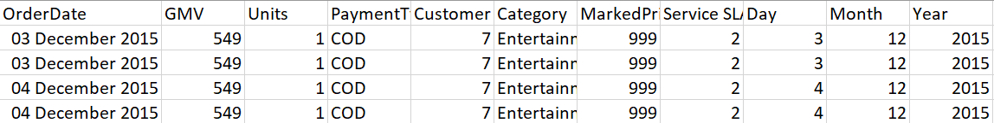

Dataset 2:

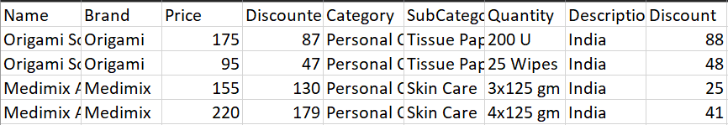

**2. IMPORTING THE DATA**

The datasets were imported using data import functions in Power Query. Power Query is a data connection technology that enables one to discover, connect, combine, and refine data across a wide variety of sources. Both the dataset we collected were imported to power query in Power BI.

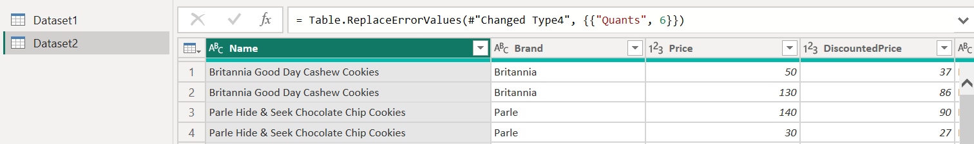

**3. TRANSFORMING THE DATA**

Data transformation was performed using Power Query to clean and shape the data. The raw data needs to be structured and transformed to make better assesments and analysis. This step included:

* Removing duplicates
* Handling missing values
* Normalizing data formats
* Aggregating data as necessary
* Filtering required data
* Creating new columns for better analysis
* 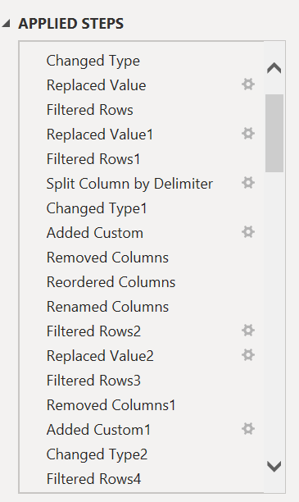Change data types

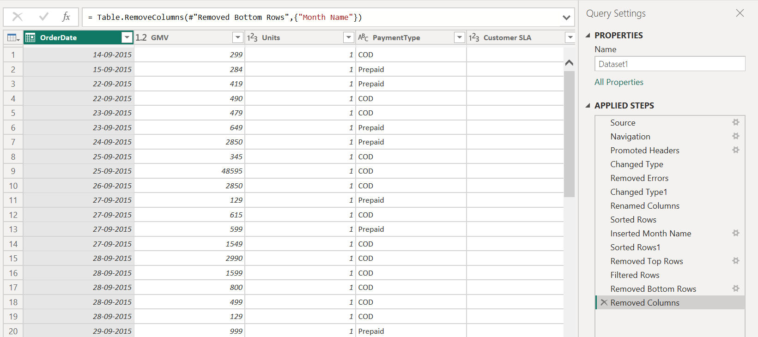

### **4. CREATION OF DAX MEASURE**

New measures were created using the DAX (Data Analysis Expressions) language. DAX is a collection of functions, operators, and constants used in formulas to calculate and return values.

Examples:

* Month on month return
* Average price
* Total brands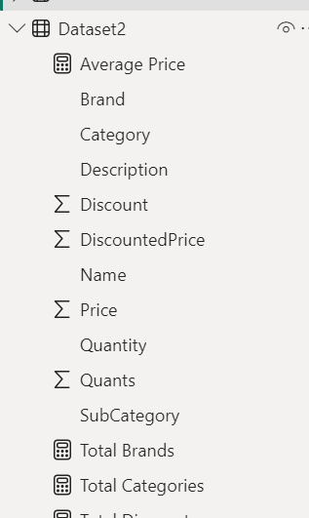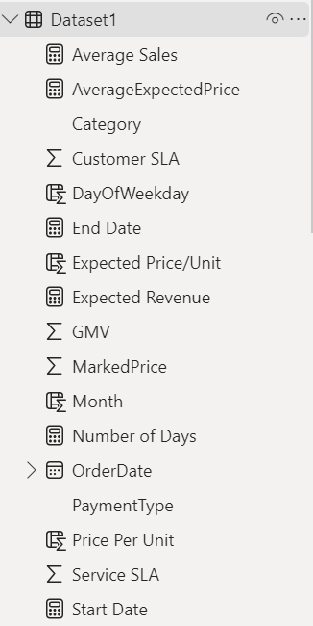

**5. Dashboard Creation**

An interactive dashboard was created to visualize the insights derived from the analysis. The dashboard includes various charts, graphs, and tables to present the data in an easily understandable manner.

Visualizations created:

* Gauge chart to track revenue
* KPI chart to compare expected and actual revenue
* Line chart to compare actual sales and GMV (Gross Merchandise Value) over time
* Line chart to compare the two types of SLAs (Service Level Agreement) over time
* Pie chart to check the preferred payment type by customers
* Donut chart to indicate the average sales over the weekends and weekdays
* Line chart to see the trend of sales across months
* Bar plots check sales over time and average sales over weekends and weekdays
* Bar plot for quantity sold per brand
* Scatter plot to compare sales made and discount provided
* Donut chart to show sales by subcategory
* Treemap to show brand dominance

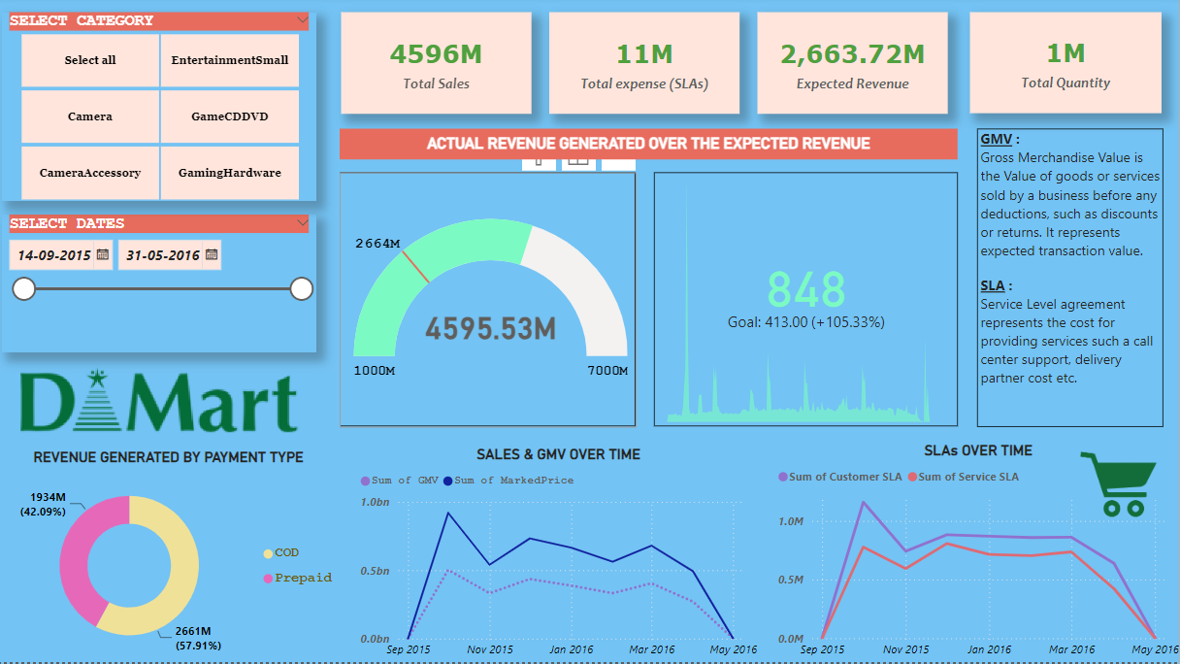Dashboards created:

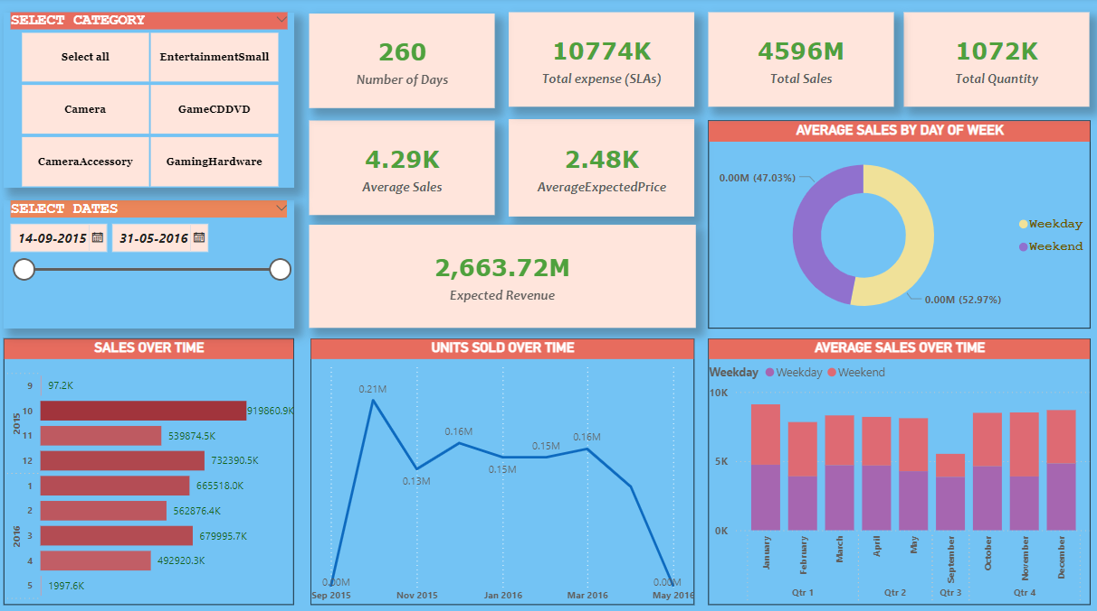

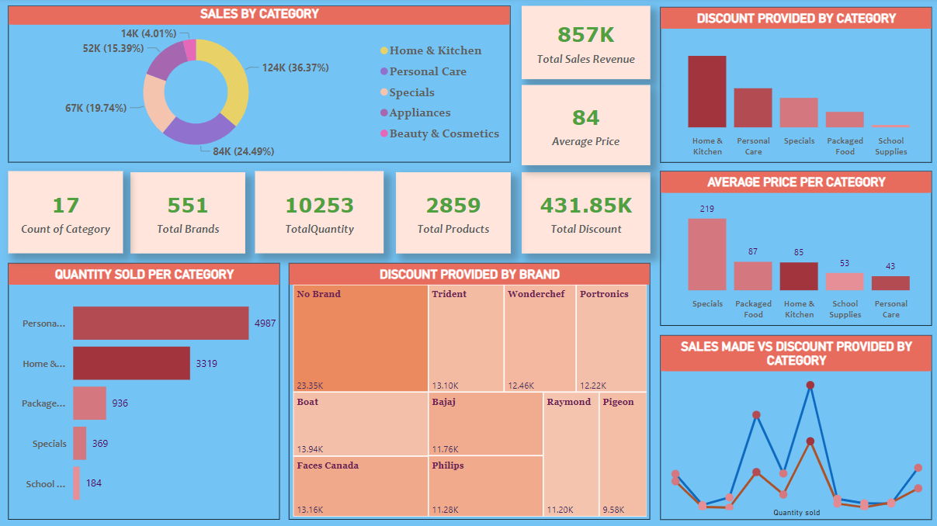

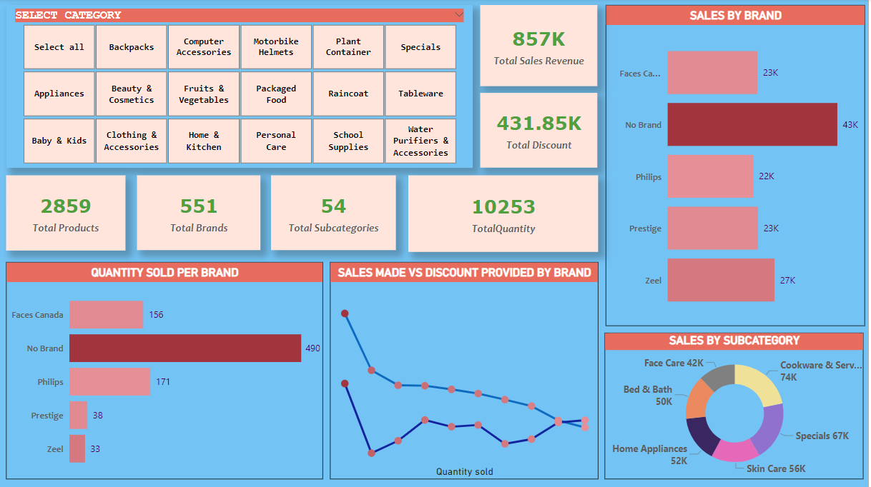

## DATA ANALYSIS

### **1. EXCEPTIONAL RETURNS**

The analysis revealed that the revenue generated was 105% more than the expected revenue. This indicates a strong performance and efficiency in operations.

### **2. REVENUE DIRECTLY PROPORTIONAL TO INVESTMENTS**

The data showed a direct correlation between the investments made in Service Level Agreements (SLAs) and the revenue generated. This suggests that higher investments in quality and service lead to higher returns.

### **3. HIGHEST SELLING MONTHS**

October was identified as the highest-selling month, generating abnormal sales. This period coincides with festive seasons, which typically drive higher consumer spending.

### **4. DISCOUNTS ATTRACT BUYERS**

Categories offering higher discounts were found to generate more revenue. This indicates that discounts are a significant motivator for customer purchases

.

### **5. CATEGORY IN DEMAND**

Home and kitchen products were identified as major contributors to sales. This suggests a high demand for these categories among customers.

### **6. BRAND NAME OVER DISCOUNTS**

Sales data showed that in most categories, the brand name was more important to customers than the discount provided. This highlights the value of brand loyalty and recognition.

## ACTIONABLE INSIGTHS AND RECOMMENDATIONS

### **1. INCREASE INVESTMENT IN SERVICE QUALITY**

Investing more in service quality, such as customer care and faster delivery, could lead to higher returns. Improved service can enhance customer satisfaction and loyalty.

### **2. PREPARE FOR HIGH SELLING MONTHS**

During high-selling months like October and December, more part-time employees and additional stock should be prepared to handle the increased demand. These months are typically hectic due to festive seasons.

### **3. PROVIDE DISCOUNTS ON LESSER SELLING CATEGORIES**

Categories with lower sales can attract more customers by offering discounts. As discounts are proportional to sales, this strategy can boost sales in less popular categories.

### **4. ALLOCATE BIGGER SPACE TO POPULAR BRANDS**

Brands with higher customer demand should be given more space to sell. Encouraging popular brands can drive more sales as customers prioritize brand names over discounts.

### **5. MAINTAIN HIGH STOCKS OF IN-DEMAND CATEGORIES**

Categories such as home and kitchen products, which are in high demand, should always have a higher variety and stock available to meet customer needs.

### **6. MAINTAIN BUSINESS MODEL CONSISTENCY**

The current business model of DMART has shown excellent results. Hence, major changes are not recommended. Minor tweaks and improvements based on data insights can enhance performance.

## CONCLUSION

The data analysis performed on DMART sales data provided valuable insights into revenue and product performance. By understanding the relationship between investments, discounts, and sales, actionable strategies can be implemented to drive business success. The interactive dashboard created as part of this project will serve as a useful tool for continuous monitoring and decision-making.

**FUTURE DIRECTIONS**

* **CONTINUOS MONITORING:** Establish a system for continuous monitoring of sales data to keep track of trends and performance metrics. This will help in making timely and informed decisions.
* **ADVANCED ANALYTICS:** Implement advanced analytics techniques such as predictive modelling and machine learning to forecast demand, optimize inventory, and personalize marketing strategies.
* **CUSTOMER FEEDBACK INTEGRATION:** Incorporate customer feedback into data analysis to gain a deeper understanding of customer preferences and improve service quality.
* **EXPANSION OF ANALYSIS SCOPE:** Extend the analysis to include more variables such as geographic locations, customer demographics, and competitor analysis to gain a holistic view of the market dynamics.

## APPENDICES

### **APPENDIX A: SAMPLE DATA TRANSFORMATION**

* **HANDLING MISSING VALUES:** Replaced null values in the 'Price' column with the average price of the respective category.
* **REMOVING DUPLICATES:** Removed duplicate rows based on 'Order Date' and 'Customer SLA.'

### APPENDIX B: SAMPLE DAX MEASURES

* **Total Revenue:** Total Revenue = SUM('Sales'[GMV])
* **Average Discount:** Average Discount = AVERAGE ('Products'[Discounted Price] / 'Products'[Price])